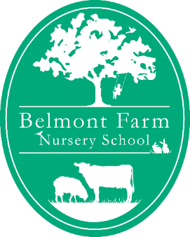

Belmont Farm Nursery School Term Dates 2021 For Funding
Spring Term

Term Starts Monday 4th January 2021
Term Ends Friday 16th April 2021

Summer Term

Term Starts Monday 19th April 2021
Term Ends Friday 23rd July 2021

Autumn Term

Term Starts Monday 9th August 2021
Term Ends Thursday 23rd December 2021

The nursery is closed on Weekends, Bank Holidays, Staff Training Days and between Christmas Day and the New Year.

Staff Training Days
The nursery is closed on the following days for annual staff training and deep cleaning:
Summer term Tuesday 3rd August
Wednesday 4th August
Thursday 5th August
Friday 6th August
Autumn term Friday 24th December

NB: For the avoidance of doubt if your child attends on any of the closure dates SPECIFIED in this letter you still pay for the session

